**ACCOLADE ELECTRONICS PVT. LTD.**



**Requirements document for Raspberry-Pi based tool for CAN simulation & debug log collection**

|  |
| --- |
|  |

|  |  |  |  |
| --- | --- | --- | --- |
| **Document No** | **Ver.** | **Reason for Revision** | **Date** |
| AEPL051400 028 V0 | 0 | Initial Release | 04-09-2024 |

|  |  |  |
| --- | --- | --- |
| Prepared By: | Verified By: | Approved By: |
| Manoj B | Prathamesh D | Prathamesh D |

* **Requirements for Raspberry Pi Tool:**

1. Tool will be used for the collecting the debug logs of field trail devices.
2. Tool has memory card to store the debug logs.
3. CAN tool with DBC file connected to USB port of Raspberry Pi based tool to send continuous CAN data to device.
4. RS 232 Serial Cable is connected to another USB port of Raspberry Pi based tool to collect the debug logs & store it into the memory.
5. Tool is supposed to collect the logs of field trail device without Jig & PC.
6. Power & IGN signals will be taken from the vehicle mobile charging socket.
7. After field trail transfer the logs to PC for debugging (Manually).

* **Actions need to take:**

1. Need to finalize Raspberry Pi board version (Compatible with 12V DC).
2. Need to finalize RS485 CAN HAT board version (Compatible with our DBC file).
3. Need to check feasibility for storing capacity of debug logs w.r.t. memory capacity of Raspberry Pi.
4. Validate integration feasibility between CAN & Raspberry Pi board.
5. Need to check feasibility for PWR & IGN connection through vehicle mobile charging point.

* **Benefits:**

1. Collecting the real time logs at the time of vehicle is in moving.
2. It reduces the Jig dependency.
3. It reduces the Manpower dependency.
4. It reduces the PC dependency.

* **Proposed design:** Raspberry-Pi based tool for CAN simulation & debug log collection

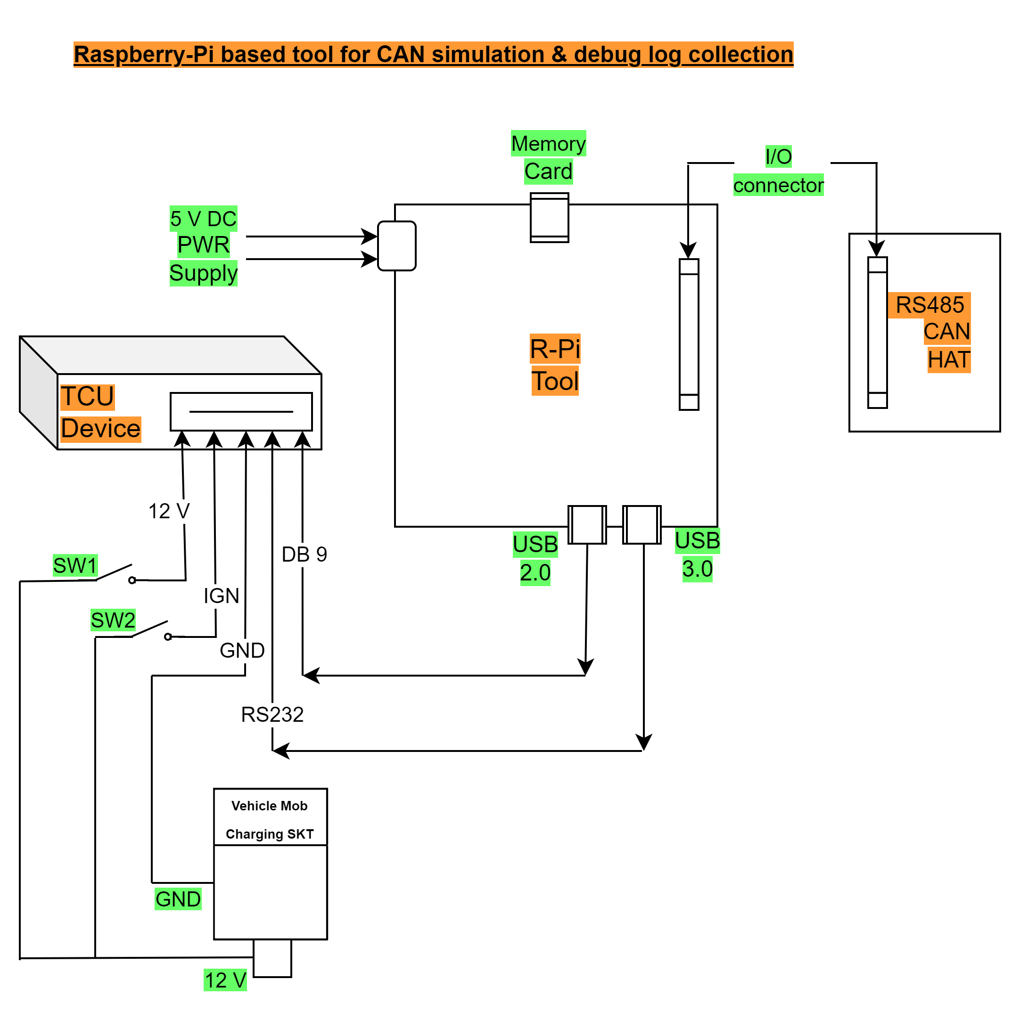

**Note: The requirements can be changes as per further modifications/development requirements.**